|  |  |  |  |  |  |
| --- | --- | --- | --- | --- | --- |
| MEMO | | | | |  |
| To: | Hunter and Central Coast Regional Planning Panel | | | | |
| From: | Scott Fatches, Development Planner | | | | |
| File: | DA/226/2022 | **Reference:** | PPSHCC-167 | Date: | 19 May 2023 |
| Subject: | Supplementary information additional Ausgrid response for 31-33 Smith Street, Charlestown | | | | |

As part of the assessment process, Council referred the application to Ausgrid for comment under [Section 2.45](https://protect-au.mimecast.com/s/3zJRCzvk3MHM0gpwUXUA4Y?domain=legislation.nsw.gov.au) the *State Environmental Plan (Transport and Infrastructure) 2021* (*Transport and Infrastructure SEPP*) and received Ausgrid’s response under Section 2.45(2) on 4/12/2022.

Ausgrid’s response indicated the design of the development would not encroach on the minimum clearances for any overhead mains and provided conditions for approval (refer to Appendix 1).

Amended information provided by the applicant on 21/04/2023 was not initially referred to Ausgrid as there was no change to the street setback of any structure.

In the process of loading re-referral to Transport for NSW on 2/05/2023, Council unintentionally included a referral to Ausgrid in the NSW Planning Portal. As Council’s Assessment Officer was unaware of this error, the development proceeded on the basis of Ausgrid initial response dated 4/12/2022.

Ausgrid provided an additional response to Council on 19/05/2023 (please note the correspondence was incorrectly dated as 4/12/2022 which was the date of their original response). This response raised concerns with the proximity of the proposed multilevel carpark and signage to the existing overhead mains in Smith and Frederick Street (refer to Appendix 2 below).

As there was no change to setback of the structure and the application has proceeded on this basis Council contacted Ausgrid to discuss the matter. Ausgrid confirmed there was only a minor potential for encroachment of clearance distance and this could be clarified prior to issue of any construction certificate. Ausgrid’s email response attached as appendix 3 confirms their satisfaction with proposed condition 14 to ensure compliance with the required separation distance and if required implement appropriate mitigation measures.

Proposed conditions 14 is provided below, please note this condition sits within the prior to Construction Certificate section of Council’s draft conditions suite.

**14. Ausgrid Requirements**

The written requirements of Ausgrid for the development shall be obtained and complied with.

Should you have any further questions, or require further information to assist in the Panel’s determination of the application, please contact me on 0438 268 841 or sfatches@lakemac.nsw.gov.au.

Scott Fatches

Development Planner

Development Assessment & Certification

**Appendix 1 – Ausgrid initial response (received 4/12/2022)**

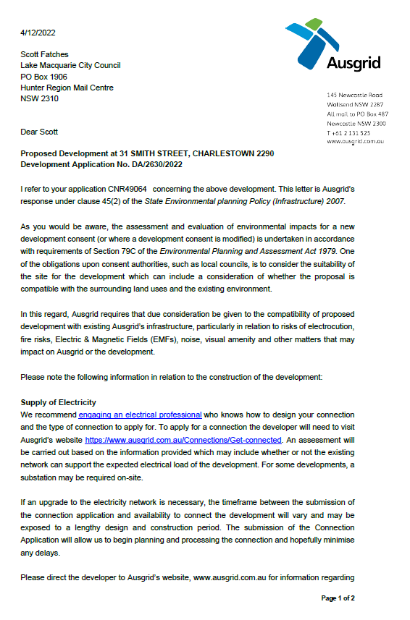

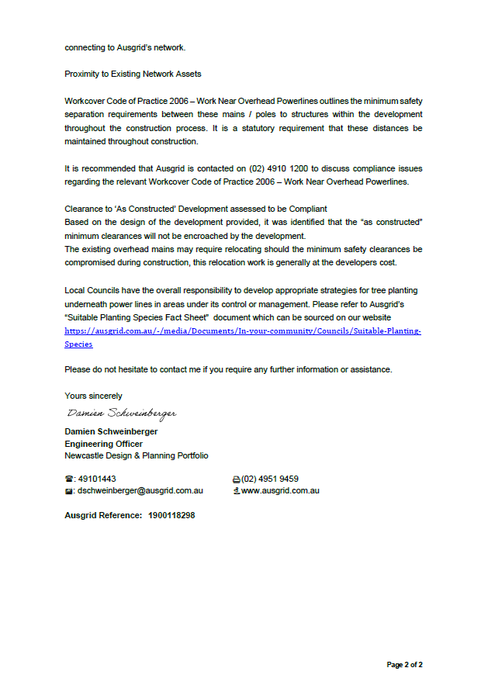

**Appendix 2 – Supplementary Ausgrid response (received 19/05/2023)**

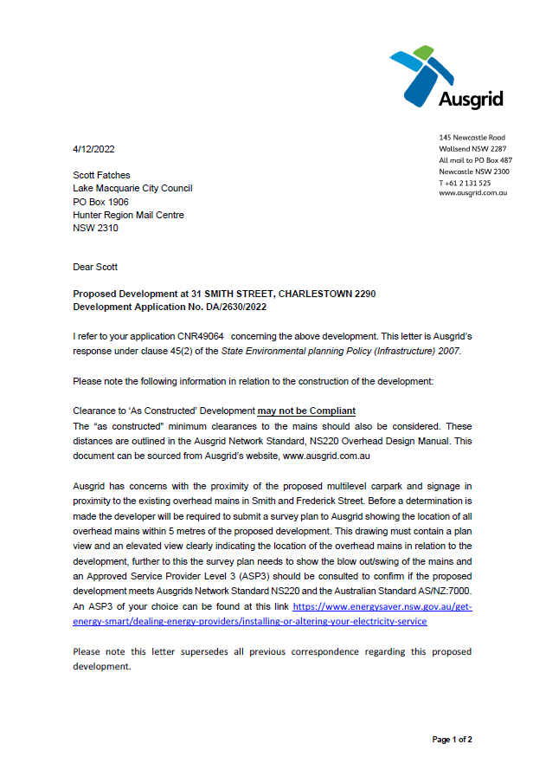

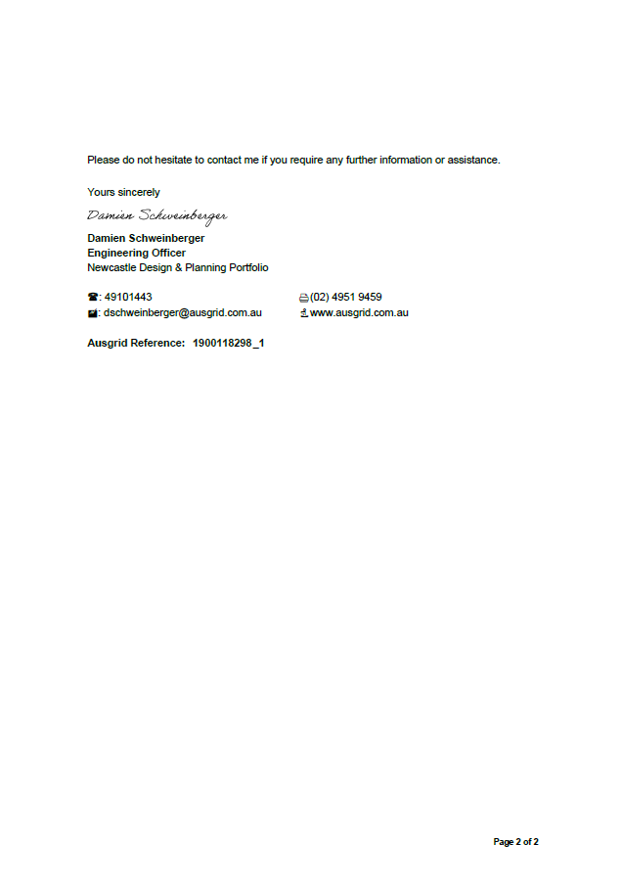

Appendix 3 – Correspondence with Ausgrid

